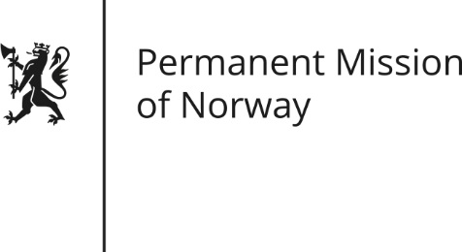

STATEMENT
Universal Periodic Review (UPR): SOUTH SUDAN
by First Secretary, Paul Bjørdal

Monday 7 November 2016

Norway welcomes the delegation of South Sudan and commends the ratification of core conventions such as the CEDAW and the CRC. We recommend the ratification of the ICCPR and ICESCR.
Norway remains gravely concerned about the human rights situation in South Sudan. Since the outbreak of violence in 2013, serious human rights violations have taken place. This includes indiscriminate targeting of civilians, shocking levels of sexual violence and oppression of civil society, human rights defenders and the media.
We recommend that the government of South Sudan:
- Immediately desists from violations of human rights, including attacks on civilians and unlawful killings, acts of rape and sexual violence, arbitrary detentions, abductions and looting.
- Ends impunity for human rights violations and launch credible, transparent, and comprehensive investigations into all allegations of violations of international humanitarian and human rights law, including those possibly constituting international crimes.
- Takes concrete steps to ensure freedom of expression, including for civil society and the media, and ensures that harassment, threats, unlawful detainment and intimidation of these groups by the national security services, end immediately.
- Cooperates fully with the UN Commission on Human Rights for South Sudan and the OHCHR.

